Week 5 quiz Theory
Question 1: The term "dynamic routing" means?
A. Every packet between a source host and a destination host will take a different path
B. Routers are learning about routes from other routers automatically
C. The speed the packet travels can change
D. The routes through the network are not stable and change frequently
Question 2: Which field in the IPv4 header is used to prevent a packet from traversing a network endlessly?
A. Time-to-Live B. Acknowledgment Number
C. Sequence Number D. Differentiated Services
Question 3: What is the correct static routing table entry on Router A so that PC0 can reach PC2?
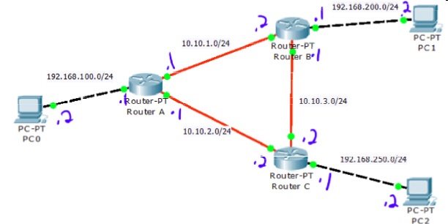
A. Network 10.10.2.0/24 Next hop -> 192.168.250.1
B. Network 192.168.100.0/24 Next Hop -> 192.168.250.1
C. Network 192.168.250.0/24 Next hop -> 192.168.250.1
D. Network 192.168.250.0/24 Next hop -> 10.10.2.2
Question 4: A packet is sent from PC0 to PC1 with the TTL field set to 1. Where will the packet be dropped?
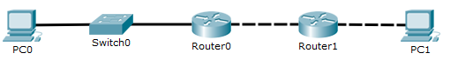
A. Router1 B. Switch0 C. PC1 D. PC0 E. Router0
Question 5: What is the purpose of the Network Layer? Select 2 answers.
A. Switching: Move an incoming frame to the outgoing interface.
B. Reordering: ensure that packets arrive in the same order they were sent.
C. Routing: Determine the path to reach relevant destination networks.
D. Forwarding: Move an incoming packet to the next hop Router interface.
E. ACK/NACK: Send an acknowledgement when a packet is received.
Question 6: What is the difference between a default gateway and default route?
A. An end device (i.e. PC) uses the default gateway whereas a router and an Ethernet Switch use a default route.
B. An end device (i.e. PC) uses the default gateway whereas a router uses a default route.
C. Both terms are used inter-changeably.
D. An end device (i.e. PC) uses the default route whereas a router uses a default gateway.
Question 7: For the network diagram and routing tables, what path is taken by a message travelling from PC0 to PC1? All Masks are 255.255.255.0.
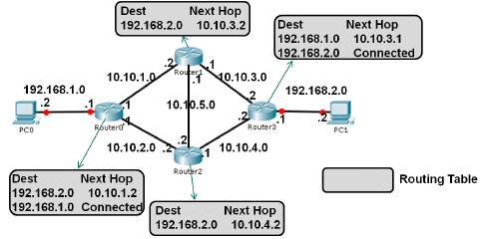
A. Router0, Router1, Router3, PC1 B. Router0, Router1, Router2, Router3, PC1
C. Router0, Router2, Router3, PC1 D. Router3 sends frames back to Router0 so the packet will loop
E. Router3, Router2, Router0, PC1

